# Step by step building restful GET API with C#.NET Entity Framework from Stored Procedure

1. Run visual studio 2013
2. File>New>Project>Web>ASP.NET MVC 4 Web Application

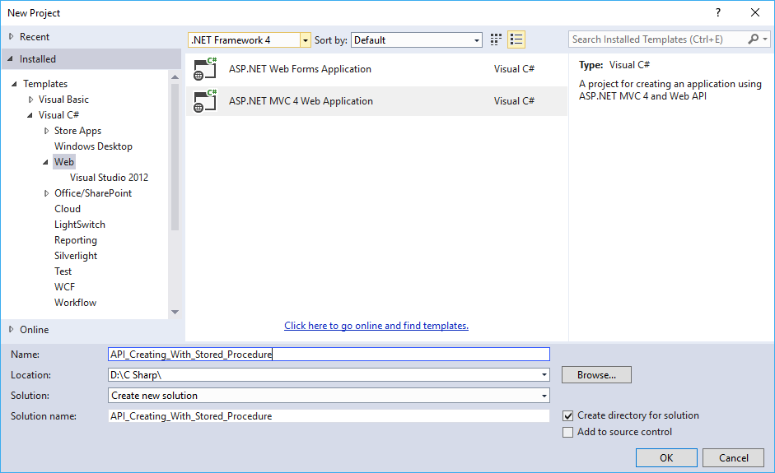

1. Name your application
2. Select Web API

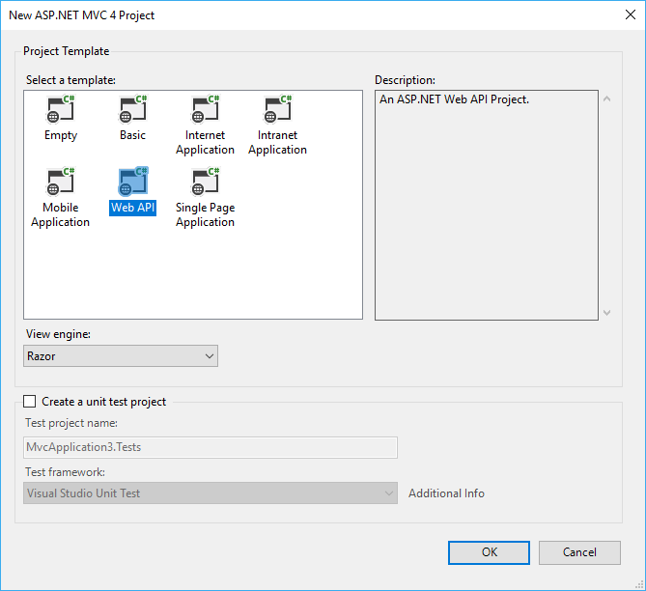

1. Project has been opened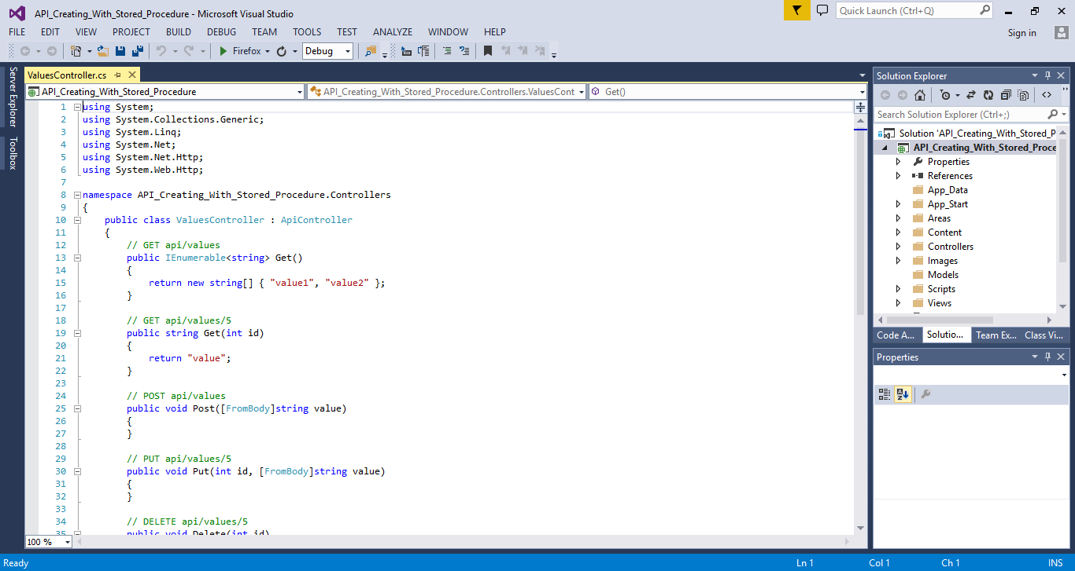
2. Right click on Model
3. Add>New Item
4. Select Data
5. Choose ADO.NET Data Model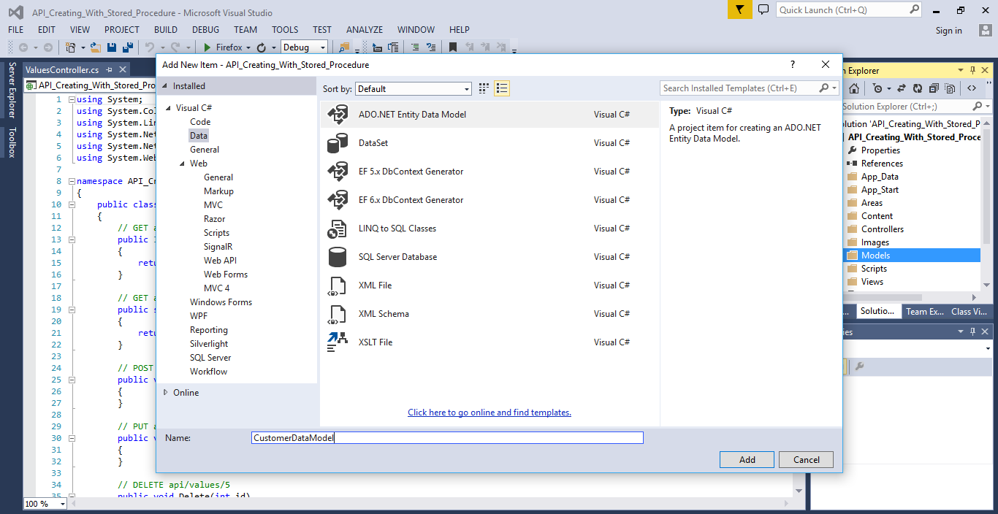
6. Give Model name
7. Select Empty EF Designer Model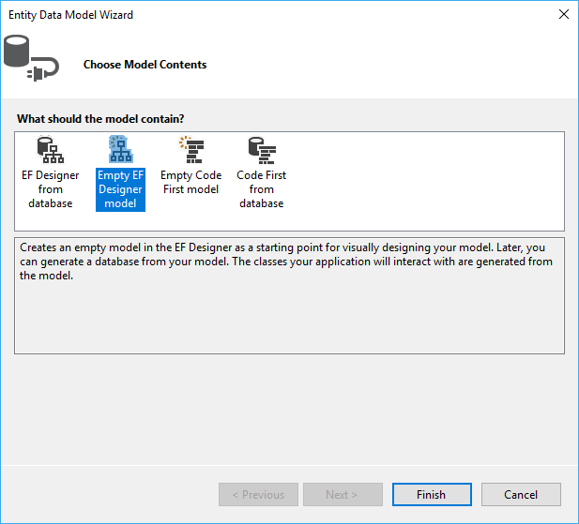
8. Click on Finish
9. Click on Model Browser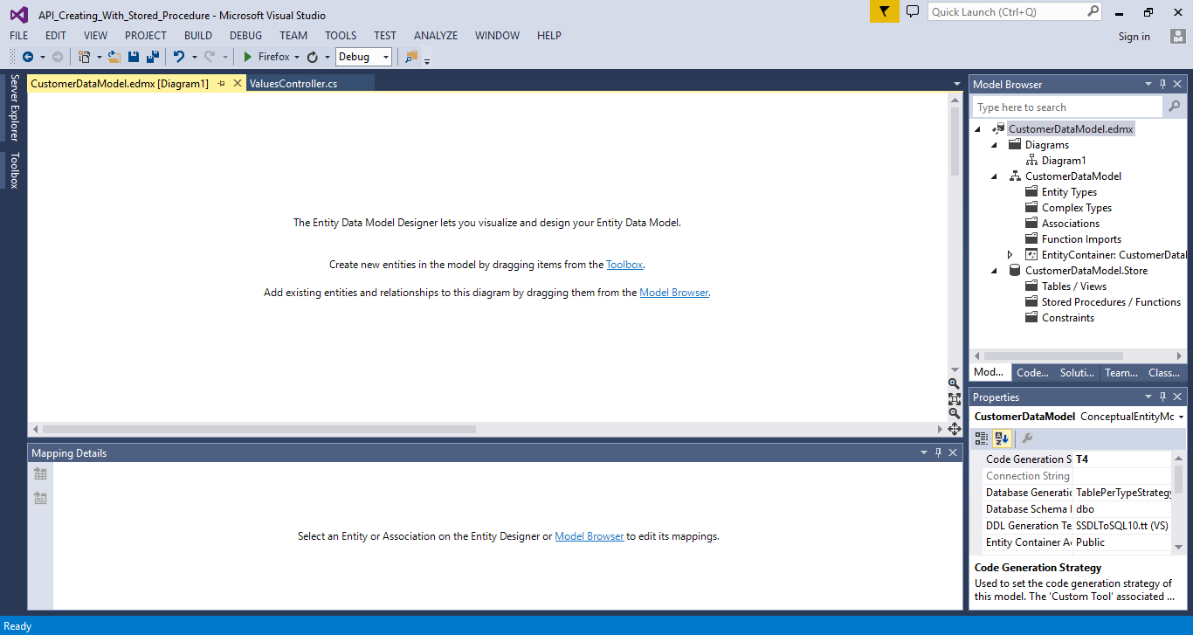
10. Right click on Stored Procedure/ Functions
11. Click on New Data Connection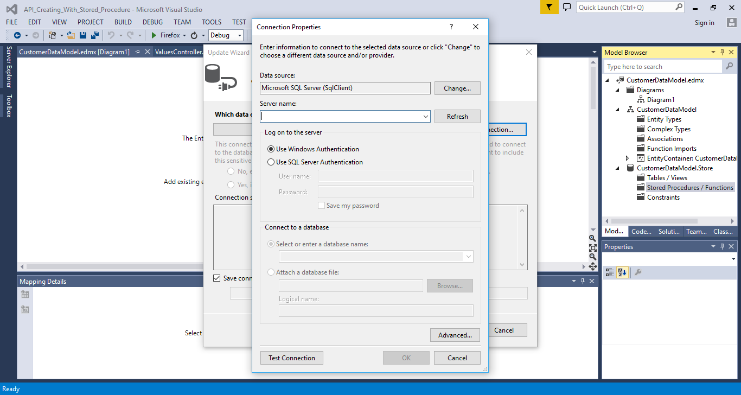
12. Input server name and database name

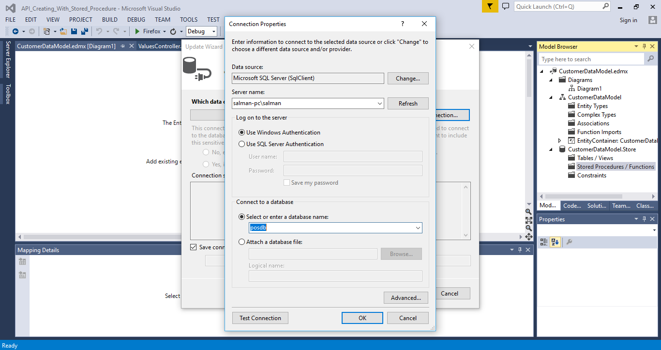

1. Memorize Entity name

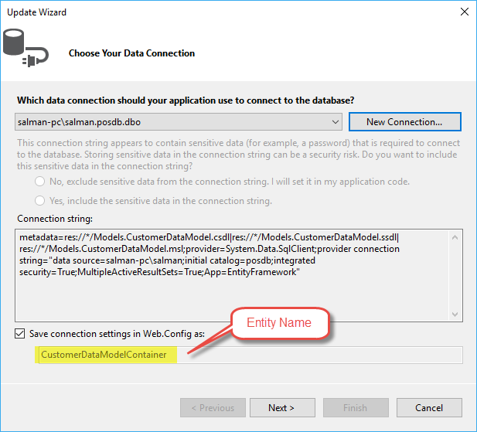

1. Go to Next
2. By default, Entity 5.0 is selected

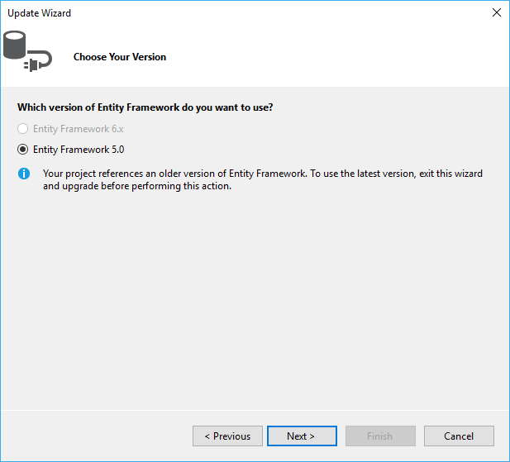

1. Go to Next
2. Select stored procedure

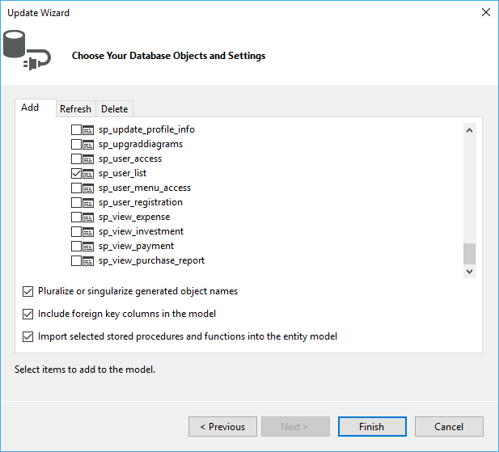

1. Click on Finish button
2. Build your application
3. Go to solution explorer
4. Right click on controller
5. Add new controller
6. Give controller name

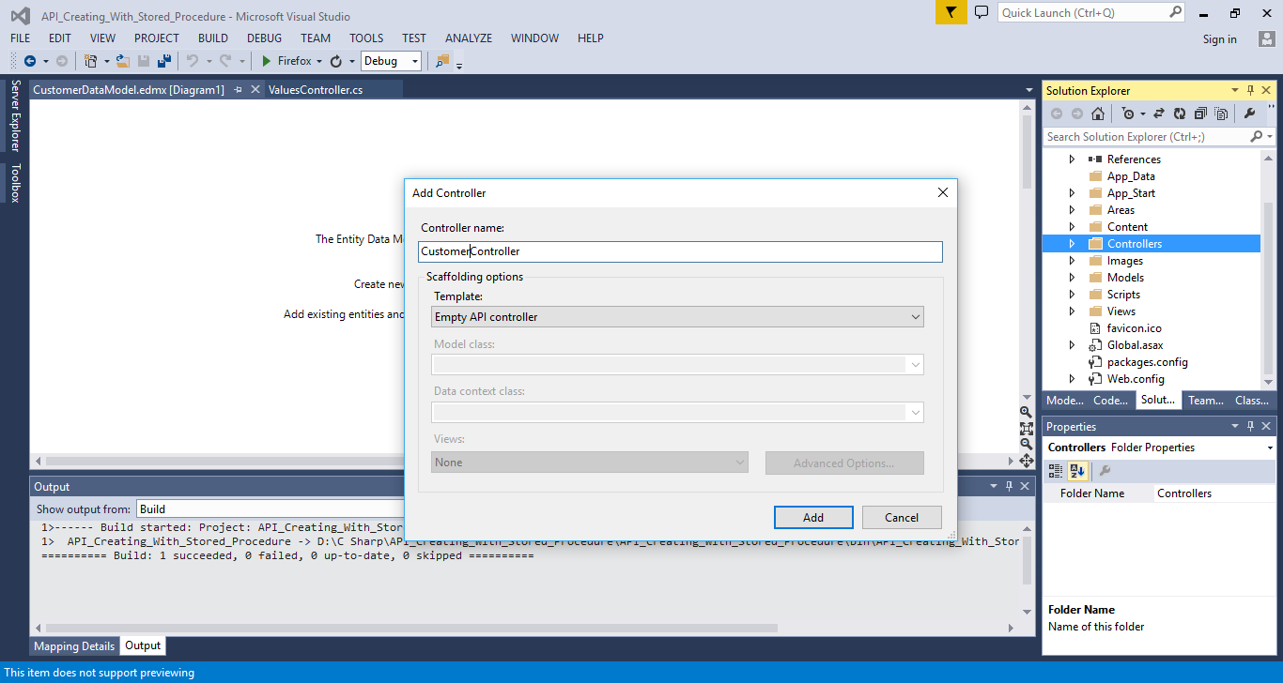

1. Select Empty API Controller
2. Click on Add
3. Go to project properties
4. Select Target Framework as 4.5

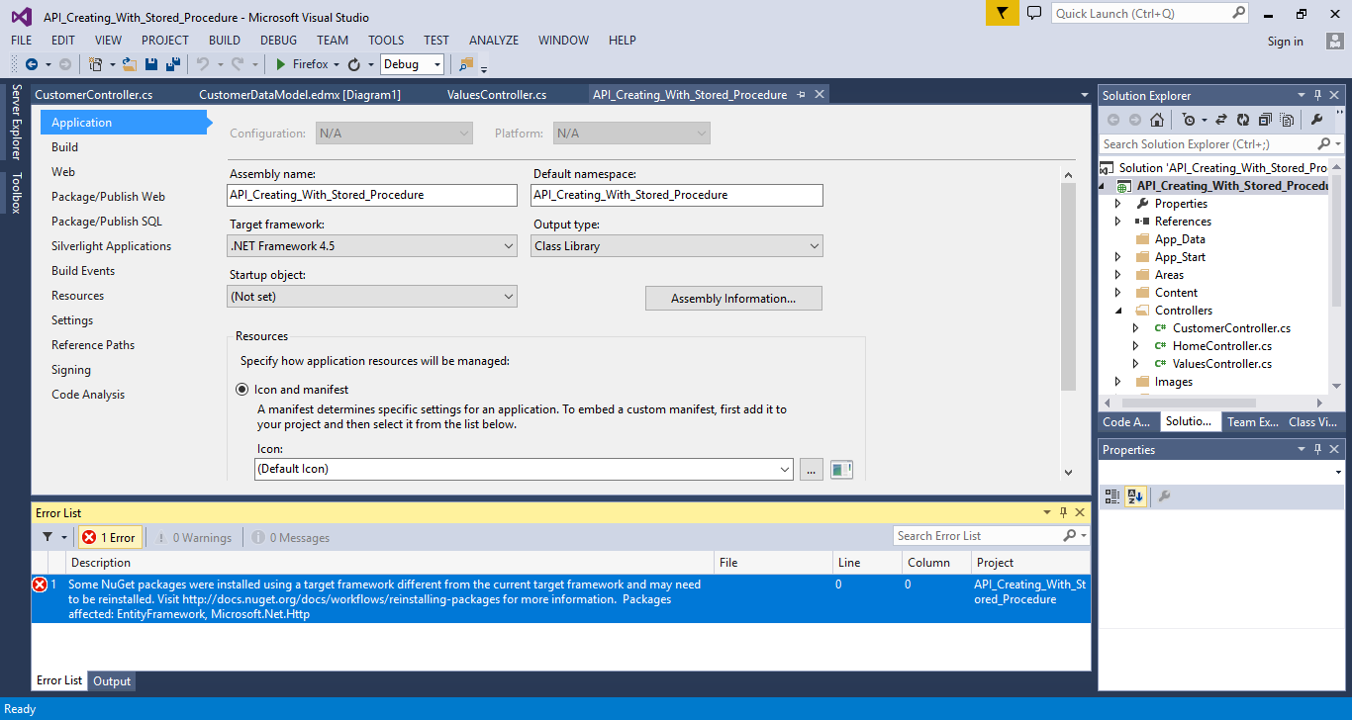

1. Write following code in the code window:

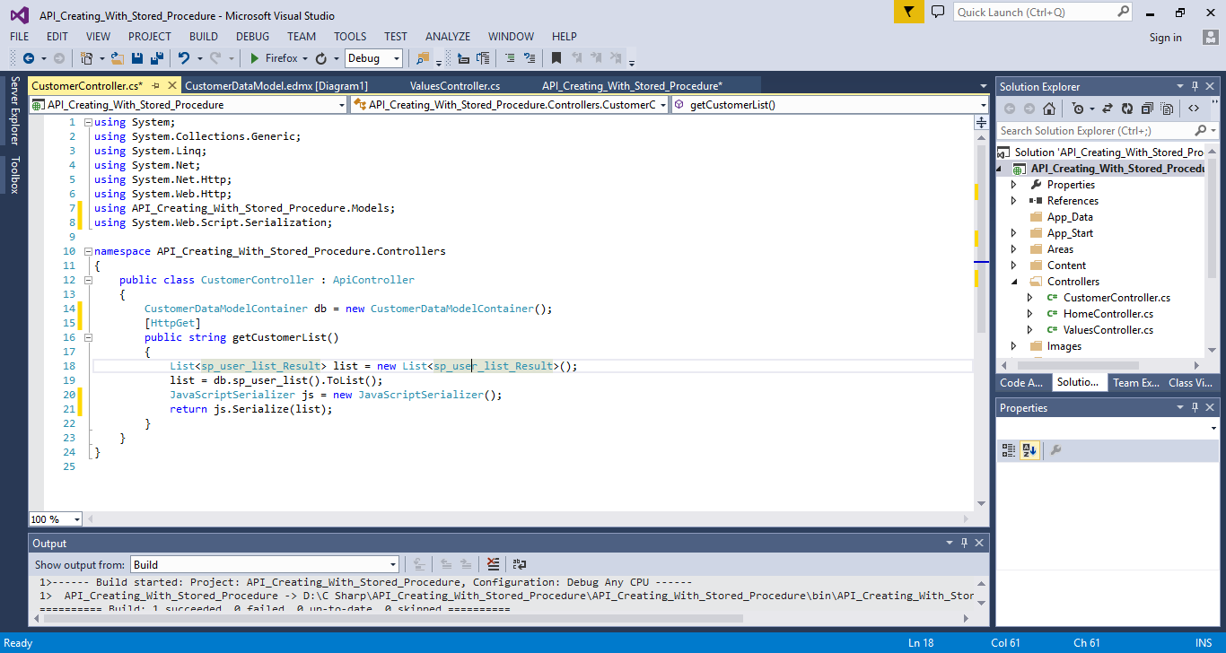

1. Build and run your project
2. If you want to add new function, then go to AppStart>WebAPI.Config
3. Rewrite RouteTemplate as “routeTemplate: "api/{controller}/{action}/{id}",”

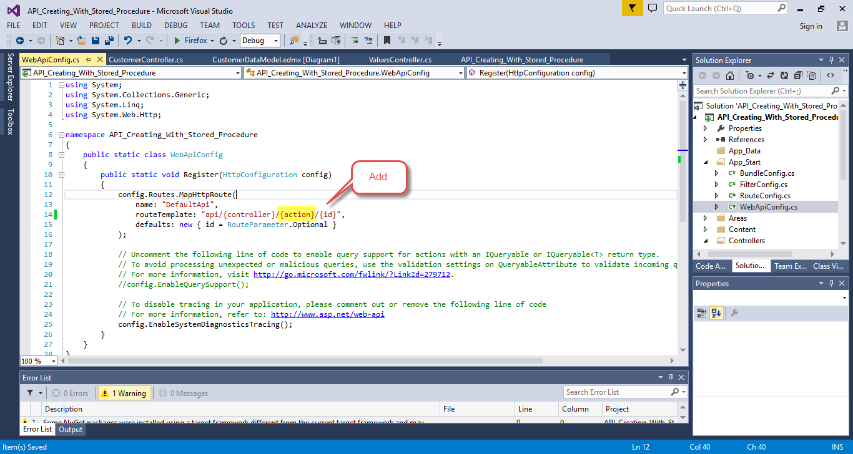

1. URL Format should be [http://baseurl/api/{controller}/{action}](http://baseurl/api/%7bcontroller%7d/%7baction%7d)
2. Output:

